Calil Amaral

TÍTULO AQUI

Documento submetido ao Programa de Pós-Graduação em Engenharia Mecânica da Universidade Federal de Santa Catarina para a Qualificação do mestrado no Programa.

Orientador: Prof. Dr. Milton Pereira

Coorientador: -

Área de concentração: Fabricação.

Florianópolis

2019

SUMÁRIO

1 INTRODUÇÃO 3

1.1 OBJETIVOS 4

1.1.1 Objetivo geral 4

1.1.2 Objetivos específicos 4

2 REVISÃO BIBLIOGRÁFICA 5

2.1 LASER 5

2.2 ADDITIVE MANUFACTURING 7

2.2.1 Directed Energy Deposition 8

2.2.2 Powder fed Directed Energy Deposition Laser (DED-L) 9

2.2.3 Process description 10

2.2.4 Thermal cycles and resulting properties 12

3 MATERIAIS E MÉTODOS 13

3.1 METODOLOGIA DE ENSAIOS E DESENVOLVIMENTO 13

3.2 RECURSOS TÉCNICOS 14

2.1.1. Sistema laser 14

3. CRONOGRAMA DE TRABALHO 15

4 BIBLIOGRAFIA 15

# INTRODUÇÃO

O desenvolvimento de novos produtos e a modificação de produtos existentes, partem do entendimento das necessidades do cliente, que são traduzidas para requisitos e restrições técnicas, preferencialmente mensuráveis, do produto. Essas características devem representar tão bem quanto possível, a percepção do que o cliente entende por valor.

Cada cliente tem seu conjunto de valores, numa ordem de relevância particular. Para clientes da indústria metal mecânica, por exemplo, esses valores costumam ter relação direta com custo, integridade estrutural, vida útil e nível de variações geométricas do produto, para citar alguns. Nesse nicho de mercado, produtos geralmente tomam forma de equipamentos compostos por subsistemas e componentes que desempenham funções bem definidas.

Dentre as possíveis funções de um componente, as de natureza estrutural tem posição de destaque no processo de desenvolvimento, sendo que a compreensão das condições de contorno de cada peça determina um importante marco do projeto. É a partir dessa etapa que se passa a discutir a escolha do material e a determinar a geometria final do componente, respeitando a requisitos quantitativos como o limite de tensão e deslocamento máximos permissíveis e a restrições geométricas de processo como ângulos de inclinação, raios de curvatura e espessuras mínimas de parede.

Dentre os processos de fabricação existentes, os de manufatura aditiva (MA), conhecidos por serem capazes de fabricar geometrias complexas, camada por camada, têm ganhado atenção nas últimas décadas. Dentro dessa categoria de processos, a tecnologia de Deposição por Energia Direcionada (DED) a LASER alimentado por pó, se destaca como uma das alternativas para fabricação de componentes metálicos de médio e grande porte e uma das únicas capazes de criar variações de composição da liga ao longo da fabricação da geometria (Volpato, 2017).

Apesar da possibilidade de fabricação de peças com alto nível de complexidade geométrica e estrutural e baixo nível de dependência de ferramental, o processo ainda é competitivo apenas para produção de componentes especiais, de alto valor agregado e pequenos lotes de produção, apresentando também alguns desafios e limitações técnicas para sua consolidação como primeira escolha na fabricação final de componentes metálicos com função estrutural.

Um dos grandes desafios técnicos para a utilização de DED LASER na fabricação final está relacionado à mudança de paradigma de desenvolvimento, especificamente na fase de concepção geométrica dos componentes [1]. O paradigma atual, com frequência inclui a utilização de sistemas CAD para modelagem de componentes, sendo de fundamental importância que o Engenheiro de Desenvolvimento de Produtos responsável, tenha conhecimento prévio dos limites geométricos inerentes ao processo de fabricação escolhido. Da mesma forma, é desejável que as propriedades mecânicas resultantes do processo sejam conhecidas à priori, antes da materialização do componente, sendo assim possível utilizar os sistemas CAE para simular e otimizar geometrias para aplicações específicas.

Para diversos processos de fabricação já consolidados, esses limites e propriedades são bem documentados na literatura e em muitos casos, simplificações como a consideração de isotropia e homogeneidade da estrutura são aceitáveis. Por outro lado, os processos de manufatura aditiva e especialmente DED, relativamente recentes, precisam ser ainda investigados para promover melhor compreensão dos níveis de anisotropia e heterogeneidade dos componentes formados, assim como da interdependência entre forma desenvolvida, parâmetros de processamento e propriedades mecânicas resultantes [1].

## OBJETIVOS

### Objetivo geral

Levando em consideração o contexto descrito anteriormente, o presente estudo tem como objetivo geral investigar a relação entre características geométricas, parâmetros de processamento e propriedades mecânicas resultantes de componentes fabricados por DED. É de interesse do autor, que os resultados do estudo possam servir como dados de entrada para Engenheiros de Desenvolvimento especializados em projeto estrutural de componentes.

### Objetivos específicos

A fim de alcançar o objetivo geral proposto, este trabalho tem como objetivos específicos:

1. Definir os níveis dos parâmetros de processo que resultam no processamento estável de pó de ferro para fabricação das geometrias definidas:
   1. Fabricação de paredes finas;
   2. Fabricação de paredes espessas;
2. Fabricação de blocos para extração de corpos de prova para ensaios mecânicos;
   1. Maior dimensão na direção Z (direção de deposição das camadas);
   2. Maior dimensão na direção X;
   3. Maior dimensão na direção XZ;
3. Realizar ensaios de dureza, tração e compressão em material fabricado e comparar com dados de material de referência, fabricado por processo convencional;
4. Realizar estudo de caso, com aplicação prática dos dados coletados, em projeto de componente estrutural fabricado por DED LASER;

# REVISÃO BIBLIOGRÁFICA

## LASER

The term “laser” was originally an acronym for *Light Amplification by Stimulated Emission of Radiation*, characterizing a special process of light amplification, but is often used to represent a special source of light. Laser, as a special type of electromagnetic radiation, can be described by its wavelength (λ) and intensity (I), differing from general light in its high degrees of directionality, monochromaticity and coherence [2].

The history of laser began with an appropriate description of electromagnetic radiation formulated by Maxwell in 1873. The following discoveries included the processes of *spontaneous emission* and *absorption* and the process of *stimulated emission* postulated by Einstein in 1917. In 1960, Theodore Mainman reported about the pulsed laser activity of a ruby laser for the first time [3].

Table 1 - Some important commercial lasers. Adapted from [2].

|  |  |  |
| --- | --- | --- |
| **Laser** | **Wavelength** | **Average power range** |
| Carbon dioxide (CO2) | 10,6 µm | Milliwatts to tens of kilowatts |
| Nd:YAG | 1,06 µm | Milliwatts to hundreds of watts |
|  | 532 nm | Milliwatts to watts |
| Nd:glass | 1,05 µm | Watts |
| Diodes | Visible and IR | Milliwatts to kilowatts |
| Argon-ion | 514,5 nm | Milliwatts to tens of watts |
|  | 448,0 nm | Milliwatts to watts |
| Fiber | IR | Watts to kilowatts |
| Excimer | Ultraviolet | Watts to hundreds of watts |

Since 1960, different types of laser have been developed as listed in Table 1, greatly varying in terms of dimensions, output power and emission wavelength (λ) [3], the last characteristic being of special importance to understand the interaction between laser and matter.

According to Poprawe [4] the fundamental principles involved in laser material processes are related to the absorption of light by the workpiece and its partial conversion to heat. The absorption depends on the wavelength and polarization of the laser light and also on the material physical properties as well as the characteristics and geometry of the workpiece surface [4]. Figure 1 illustrates absorption coefficients of different metals as a function of the wavelength of the incident radiation and shows that certain laser sources are better absorbed by specific materials.

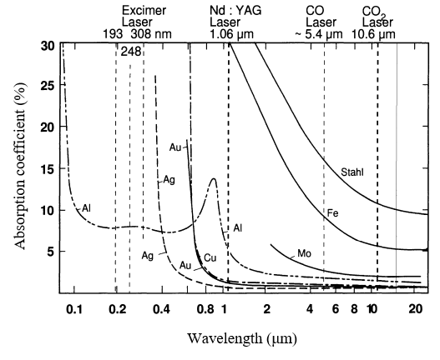

Figure 1 – Absorption coefficient of a variety of metals as function of the wavelength of the incident radiation [5].

The laser energy is not homogeneously distributed along a cross section of a laser beam and its distribution depends on the wavelength, beam quality and the focusing optics. From the irradiated surface, a heat front moves into the inner material by conduction due to the developed temperature gradients. The heat flux lead to rise in temperature, depending on the absorbed intensity, the duration of the interaction, the beam radius at the surface, the velocity of the workpiece relative to the laser beam and the thermo-physical parameters of the material like heat conductivity and heat capacity [4].

High energy intensities available at a small controllable area on the intersection between the laser beam and the workpiece surface, make the laser a well-suited tool for additive manufacturing processes. With the right combination of laser source and material, it is possible to melt and deposit metal on specific regions of a workpiece creating metallurgical bonds, layer by layer, until whole functional components are built.

## ADDITIVE MANUFACTURING

Additive manufacturing (AM) can be defined as a process of joining materials to make parts from 3D model data, usually layer upon layer, as opposed to subtractive manufacturing and formative manufacturing methodologies [6].

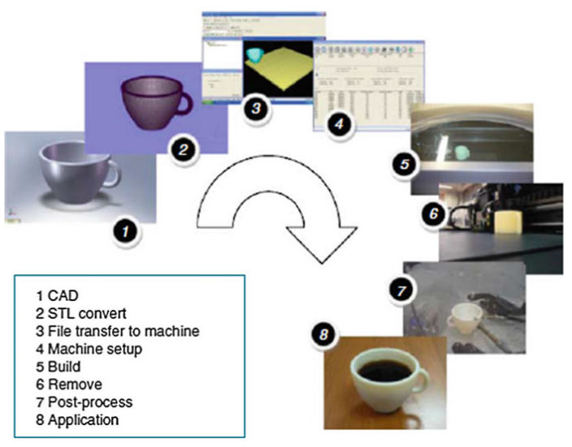

Figure 2 - Generic process of CAD to part, showing eight stages [7].

The idea was first documented in 1892 when Blanther applied the technique for building molds for topographic maps in three dimensions, but now it has developed into a highly digital manufacturing process, usually following the steps illustrated in Figure 2 to convert a digital 3D geometry into a physical part. The starting point is a 3D CAD model that is virtually sliced into thin layers with layer thickness of 20 µm – 1 mm, depending on the AM process. Based on this data the physical part is then built by repetitive deposition of single layers and locally melting the material by a heat source [8]. The part is then removed and usually post-processed before being suitable for the application.

AM methods can essentially be classified by the nature and the aggregate state of the feedstock as well as by the binding mechanism between the joined layers of the material [8]. A complete list of categories is available in Table 2, highlighting the suitability of each category to produce dense metal parts.

Table 2 - Categories of additive manufacturing and suitability for producing dense metal parts. Adapted from [6], [9], [10].

|  |  |  |  |
| --- | --- | --- | --- |
| **Category** | **Example** | **Processed materials** | **Density of metal parts** |
| Binder Jetting | 3D printing; | Metals, Polymers, Composites, Ceramics | Low |
| Directed Energy Deposition | WAAM1, Laser Cladding; | Metals | High |
| Material Extrusion | FDM2 | Thermoplastics, Waxes | - |
| Material Jetting | Polyjet | UV curable resins | - |
| Powder Bed Fusion | SLS3, SLM4 | Metals, Thermoplastics, Ceramic | High |
| Sheet Lamination | Sheet forming | Metals, Polymers, Paper | Low |
| Vat Polymerization | Stereolithography | UV curable resins, Wax, Ceramic | - |
| 1 Wire Arc Additive Manufacturing;  2 Fused Deposition Modeling;  3 Selective Laser Sintering;  4 Selective Laser Melting; | | |  |

AM has attracted much attention over the past ten years due to its inherent advantages, such as high design freedom and short lead times [8] and although AM techniques were at first limited to rapid prototyping of porous structures, recent advancements in technology made possible to reliably manufacture even dense metal parts with certain AM processes, including steel, aluminum and titanium. In the present work, one of the processes suitable for processing metal (Directed Energy Deposition) will be discussed in further detail.

### Directed Energy Deposition

Directed Energy Deposition, or DED, is defined as an additive manufacturing process in which focused thermal energy is used to fuse materials by melting as they are being deposited [11]. DED systems comprise multiple categories of machines using laser beam (LB), electron beam (EB), or arc plasma energy sources as categorized in Figure 3. Feedstock material typically comprises either powder or wire. Deposition typically occurs either under inert gas (arc systems or laser) or in vacuum (EB systems) [11]. The process was a natural evolution of welding techniques and the first of its kind was LENS ®, documented in 1998 by the Sandia Labs in Albuquerque, New Mexico [1].

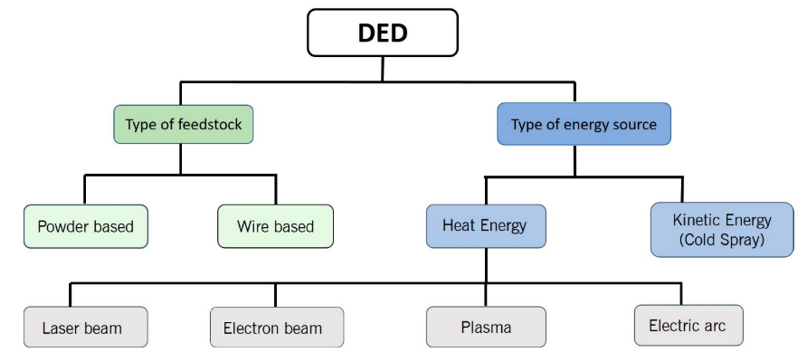

Figure 3 - Classification of Directed Energy Deposition (DED) systems [12].

### Powder fed Directed Energy Deposition Laser (DED-L)

Among the DED systems illustrated in Figure 3, in the present work we focus our attention to the laser-based process (DED-L), using powder as feedstock material. The process is well suited for manufacturing finer details when compared to arc technologies yet without using expensive vacuum chambers such as the ones needed for electron beam systems [8]. These two factors combined, make the laser systems very attractive among other DED processes.

In contrast to powder bed technologies, DED-L technology provides a high build rate and allows for larger build volumes although presenting lower layer thickness resolution. Depending on the main parameters, build rates up to 300 cm3/h can be achieved using a layer thickness of 40 μm – 1 mm. Feed rates between 4 g/min and 30 g/min are realized for the deposition of metal powder [8].

|  |  |  |
| --- | --- | --- |
|  | | |
| (a) | (b) | (c) |

Figure 4 – IN718 helicopter engine combustion chamber fabricated by a five-axis laser DED process. (a) Deposition showing the 2.5-dimensional tool path; (b) Multiaxis deposition; (c) Finished part [13].

Moreover, as the material is melted while being deposited, it is possible to use 4 or 5-axis systems, as show Figure 4, to build structures with high overhang angles, reducing or eliminating the undesired metal support structures and reducing component postprocessing time [14]. One particular benefit of this characteristic is the potential to deposit material onto curved surfaces and existing metal structures. For this reason, one of the DED technologies, referred to as laser Cladding, is often used to repair damaged parts, particularly for the aerospace industry [15].

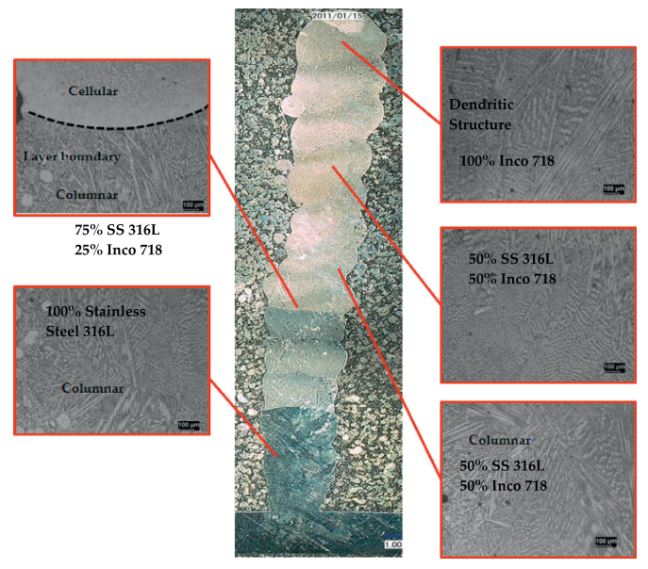

Figure 5 - Transverse cross section showing the transition between 100% 316L to 100% Inconel 718 from bottom to top [16].

Regarding the choice of feedstock material, one of the main advantages of using powder, is the capability of mixing different powders during the deposition, thus enabling the creation of gradient metal alloys in-situ, also known as functionally graded materials (FGM) as illustrates Figure 5. The concept extends the design space to components that can be made of a continuum structure that uses cost-intensive alloys in highly-loaded regions, and cheaper compositions in non-critical areas [17].

In order to make use of the full potentials of powder fed laser based DED process, a list of challenges and unanswered questions need to be addressed. This list includes uncertainties about predicting the geometry, metallurgical integrity and mechanical properties of the formed components. These outputs highly depend on interactions between laser beam, powder stream and scanning speed, which will be briefly discussed in the next sessions.

### Process description

A powder fed laser based DED system comprises five fundamental subcomponents: laser source, inert gas, powder feedstock feed mechanism, positioner and a computer control system. The process consists in the formation of a melt pool in the substrate through absorption and conversion of irradiated laser energy into heat. Simultaneously powder is fed into this pool and melts, subsequently solidifying to form a layer of deposited material as illustrated by Figure 6. A strong fusion bond between added material and substrate is achieved immediately [18].

|  |  |
| --- | --- |
|  |  |
| (a) | (b) |

Figure 6 – (a) Lateral powder supply [18]; (b) Continuous coaxial powder nozzle during the deposition. (1) Process laser beam; (2) Focalizing lens; (3) Mix of metal powder with carrier gas; (4) Shielding inert gas; (5) Deposition nozzle; (6) Schematic (left) and realistic (right) views of a powder cone; (7) Melt pool; (8) Deposited structure; (9) Substrate. Adapted from [19] and [4].

A variety of nozzle configurations are reported in the literature, from lateral to coaxial, from discrete to continuous, two of which are schematically illustrated in Figure 6 (a) and (b). The powder is delivered to the melt pool by feeders, that can be based on various working principles, one of which consists of a container from which powder flows by gravity into a slot in a rotating disk. The powder is transported to a suction unit from which it is transported by a gas stream to a powder nozzle. The volumetric powder feed rate is controlled by the dimensions of the slot and the speed of the disk [18].

The nozzle head is programmed to move along a path, previously defined by the user, and as it moves, continuously deposit material on the surface of the substrate, usually maintaining a constant distance between the nozzle tip and the surface. After forming the first layer, the nozzle moves in the positive Z direction, represented in Figure 6, and starts to add material on top of the previously deposited layer. This process repeats until the entire part has been built. A schematic view of key input and output factors that affect the stability of the process are represented in Figure 6, some of which will be described in more detail later.

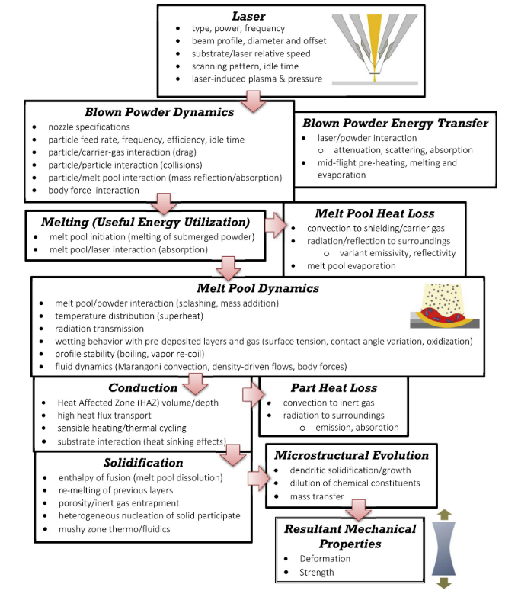

Figure 7 – Physical events occurring during DLD for given instant in time [20].

Along the process, several critical input variables schematically listed in Figure 7, interact with one another in a complex physical processes that involves light absorption, heat conduction and convection, mass diffusion and result in the geometry, microstructure, mechanical properties and other relevant characteristics [18]. The present study will focus on discussing DED-L process parameters and its relationship with the resulting microstructure and mechanical properties.

### Thermal cycles and resulting properties

During AM, a defined volume element, or voxel, of the material is usually subjected to a complex thermal cycle. This thermal cycle involves a rapid heating above melting temperature due to the absorption of the laser energy and its transformation into heat, a rapid solidification of the molten material after the heat source has moved on, and numerous re-heating and re-cooling processes when the following layers are welded and the voxel is still exposed to heat [8]. The effect is better pictured in Figure 8 (a) derived from a numerical investigation conducted by Manvatkar et. Al [21].

AM microstructure is therefore a result of the described thermal cycle. Independently of the material, a fine-grained structure has usually been observed for AM in comparison to other processes (e.g. casting) [8]. The effect can be explained by the high cooling rates of up to 12000 K/s as shown in Figure 8 (b) when compared with 1 – 100 K/s for casting [22], which itself is a result of the very local heat input and the small volumes of molten material [8].

|  |  |  |
| --- | --- | --- |
|  |  |  |
| (a) | (b) | (c) |

Figure 8 – (a) Simulated thermal cycles at three monitoring locations in the first three layers in a DED-L of 316 stainless steel at a laser power of 210 W and 12.7 mm/s speed; (b) Variation of cooling rate at three monitoring locations in the three layers. The results of the heat conduction calculations are from the literature; (c) Computed and the experimentally determined hardness values in three layers compared with heat conduction model; [21]

The temperature gradients are obviously influenced by several process parameters, e.g. the energy density, laser power, scanning speed, layer thickness and pre-heating temperature, if applied [8]. Moreover, the temperature gradients are also affected by the surrounding material, and as heat conduction in build direction is typically higher than in other spatial directions as a result of the solidified material from lower, previously built layers, anisotropy in both microstructure and properties has been reported in several studies [8].

For constant laser power and scanning velocity, the layer width and peak temperature increase while the cooling rate decreases toward the top layers as shown in Figure 8 (b) extracted from simulated results [21]. As a result, the solidified deposit usually exhibits finer grain structure close from the substrate with coarser grains towards the top. Correspondingly, the yield strength and hardness also reduce from the bottom toward the top layers [23]. Figure 8 (c) illustrates simulated values that match with experimental data.

### Influence of residual porosity in mechanical properties

With advancements in AM technology over the past years, dense metallic parts with mechanical properties comparable to conventional manufacturing methods are achievable for several material and process combinations. As porosity facilitates crack propagation and deteriorates mechanical properties, the manufacture of parts with a high density, typically greater than 99.5%, is the first goal in AM process optimization [8].

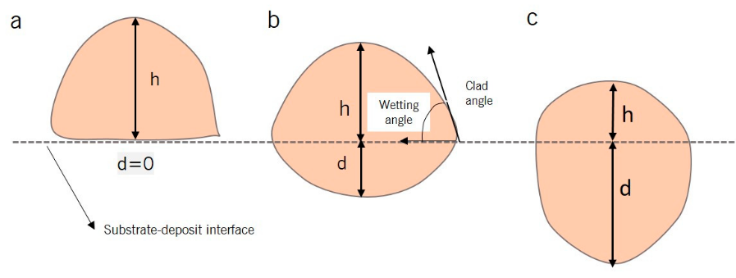

Figure 9 – (a) Zero or low penetration, meaning a lack of fusion with the substrate; (b) Optimal level of dilution (generally between 10% and 30%); (c) High d leads to keyholing [12].

Besides other influences, part density depends on the applied volume energy

|  |  |
| --- | --- |
|  | (1) |

Where is the laser power, stands for the scan speed, is the hatch distance and the layer thickness of the deposited layer. According to Herzog et. Al [8], too low energy input will result in unmolten material and thus reduced density by the formation of irregular-shaped voids. On the other hand, too high energy input will lead to higher melt pool dynamics and keyholing phenomenon resulting in spherical shaped pores formed due to entrapped gas, formed during evaporation of material, and reducing part density [8]. Figure 9 illustrates the schematics of weld pool cross sections of the above-mentioned circumstances and Figure 10 shows diagrams of the resulting pores geometry as well as a graph of the desired processing condition that generates minimum porosity.

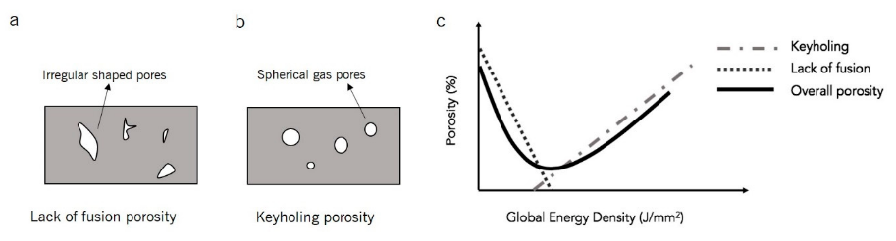

Figure 10 - Schematic showing: (a) Lack of fusion porosity (interlayer porosity), (b) keyholing porosity (intralayer porosity), and (c) the intersection of interlayer and intralayer porosity with respect volume energy [12].

### Reported mechanical properties and sampling strategy

[24]

# MATERIAIS E MÉTODOS

## METODOLOGIA DE ENSAIOS E DESENVOLVIMENTO

O projeto inclui etapas para o desenvolvimento do sistema de alimentação dinâmica, integração do sistema ao microcontrolador e fonte de soldagem para o processo laser *cladding*. Os critérios de avaliação dos resultados alcançados ao longo do projeto serão baseados em dois aspectos principais. Um deles é a capacidade de integração entre a fonte de soldagem, microcontrolador e o próprio alimentador, o que implica em um levantamento de motores e drivers de potência compatíveis com as exigências do projeto.

Outro aspecto diz respeito à capacidade do sistema de executar sua função principal, ou seja, comprovar a integração mecânica, eletroeletrônica e computacional para a alimentação dinâmica e técnica de arame quente para o processo laser *cladding.* Para tal, o sistema será avaliado em relação a frequência de avanço e recuo do arame, assim como precisão e aumento de produtividade em relação ao processo convencional.

## RECURSOS TÉCNICOS

### Sistema laser

Os ensaios e construção do protótipo serão realizados no laboratório LMP. O laboratório possui um sistema de fonte LASER de fibra da IPS YLS-10000 com feixe de cerca de 300 mm no ponto focal e 880 de diâmetro. O cabeçote LASER utilizado consiste em duas partes: sistema ótico integrado ao sistema, sistema do gás de proteção como ilustrado na Figura 16.

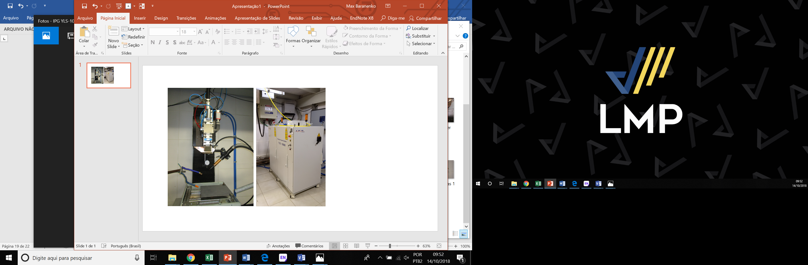

Figura 16– Esquerda Montagem cabeçote de soldagem para o processo laser *cladding;* Direita: fonte laser de fibra IPS YLS-10000 (Autoria própria).

# CRONOGRAMA DE TRABALHO

O cronograma a seguir (Quadro 1) ilustra a distribuição das principais etapas pertencentes ao projeto de dissertação de mestrado.

Quadro 1- Cronograma de atividades do projeto de dissertação. [20]

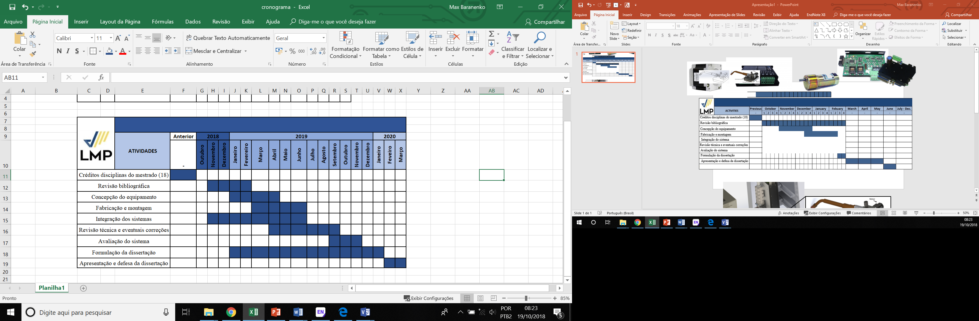

# BIBLIOGRAFIA

[1] N. Volpato *et al.*, *Manufatura Aditiva - Tecnologias e aplicações da impressão 3D*. Blucher, 2017.

[2] C. B. Hitz, J. Ewing, and J. Hecht, *Introduction to Laser Technology*. 2012.

[3] R. Poprawe, K. Boucke, and D. Hoffman, *Tailored Light 1*. 2018.

[4] R. Poprawe, *Tailored Light 2 Laser Application Technology*. 2016.

[5] G. Herziger and H. Weber, *Laser in Technik und Forschung*. 1998.

[6] ISO and ASTM, “ISO/ASTM 52900:2015(E) - Standard Terminology for Additive Manufacturing – General Principles – Terminology,” vol. i, pp. 1–9, 2019.

[7] I. Gibson, D. Rosen, and B. Stucker, *Additive manufacturing technologies: 3D printing, rapid prototyping, and direct digital manufacturing, second edition*. 2015.

[8] D. Herzog, V. Seyda, E. Wycisk, and C. Emmelmann, “Additive manufacturing of metals,” *Acta Mater.*, vol. 117, pp. 371–392, 2016.

[9] C.-J. Bae, A. B. Diggs, and A. Ramachandran, *Quantification and certification of additive manufacturing materials and processes*. Elsevier Inc., 2018.

[10] T. Caffrey and T. Wohlers, “Additive manufacturing state of the industry,” *Manuf. Eng.*, 2015.

[11] ASTM and ISO, “F3187 − 16: Standard Guide for Directed Energy Deposition of Metals 1,” pp. 1–22, 2019.

[12] A. Dass and A. Moridi, “State of the Art in Directed Energy Deposition: From Additive Manufacturing to Materials Design,” *Coatings*, 2019.

[13] R. Liu, Z. Wang, T. Sparks, F. Liou, and J. Newkirk, *Aerospace applications of laser additive manufacturing*. Elsevier Ltd, 2016.

[14] J. Xu, X. Gu, D. Ding, Z. Pan, and K. Chen, “A review of slicing methods for directed energy deposition based additive manufacturing,” *Rapid Prototyp. J.*, vol. 24, no. 6, pp. 1012–1025, 2018.

[15] M. Molitch-Hou, *Overview of additive manufacturing process*, vol. 83, no. 1. Mississauga: Elsevier Inc., 2018.

[16] K. Shah, A. Khan, S. Ali, M. Khan, and A. J. Pinkerton, “Parametric study of development of Inconel-steel functionally graded materials by laser direct metal deposition,” *Mater. Des.*, vol. 54, pp. 531–538, 2014.

[17] Z. Quan *et al.*, “Additive manufacturing of multi-directional preforms for composites: Opportunities and challenges,” *Mater. Today*, 2015.

[18] M. Schneider, “Laser clading with powder effect of some machining parameters on clad properties,” 1998.

[19] Manufacturing Guide, “Laser Cladding 3D, LC3D | Find suppliers, processes &amp; material.” [Online]. Available: https://www.manufacturingguide.com/en/laser-engineered-net-shaping-lens-0. [Accessed: 04-Jul-2019].

[20] S. M. Thompson, L. Bian, N. Shamsaei, and A. Yadollahi, “An overview of Direct Laser Deposition for additive manufacturing; Part I: Transport phenomena, modeling and diagnostics,” *Addit. Manuf.*, vol. 8, pp. 36–62, 2015.

[21] V. Manvatkar, A. De, and T. Debroy, “Heat transfer and material flow during laser assisted multi-layer additive manufacturing,” *J. Appl. Phys.*, vol. 116, no. 12, 2014.

[22] T. DebRoy *et al.*, “Additive manufacturing of metallic components – Process, structure and properties,” *Prog. Mater. Sci.*, vol. 92, pp. 112–224, 2018.

[23] V. D. Manvatkar, A. A. Gokhale, G. Jagan Reddy, A. Venkataramana, and A. De, “Estimation of melt pool dimensions, thermal cycle, and hardness distribution in the laser-engineered net shaping process of austenitic stainless steel,” *Metall. Mater. Trans. A Phys. Metall. Mater. Sci.*, vol. 42, no. 13, pp. 4080–4087, 2011.

[24] J. S. Keist and T. A. Palmer, “Role of geometry on properties of additively manufactured Ti-6Al-4V structures fabricated using laser based directed energy deposition,” *Mater. Des.*, vol. 106, pp. 482–494, 2016.